1. Write an algorithm and draw a flowchart that will read the two sides of a rectangle and calculate its area and perimeter.

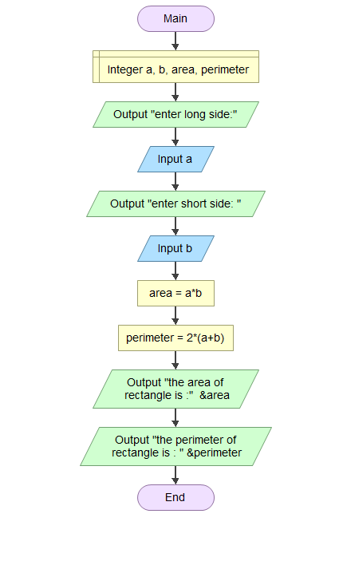

2. Draw a flowchart to find all the roots of a quadratic equation ax2+bx+c=0.

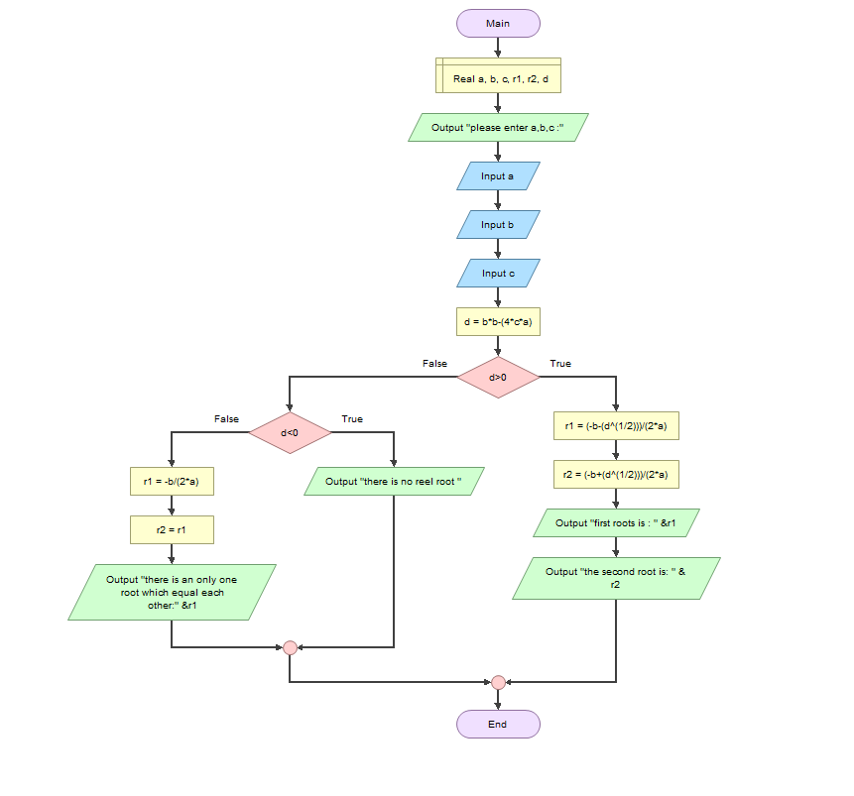

3. Print Hello World 10 times

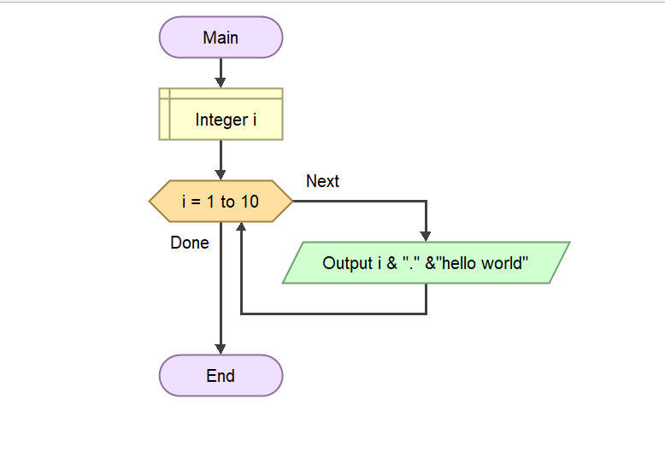

4. Draw a flowchart to find the sum of the first 50 natural numbers

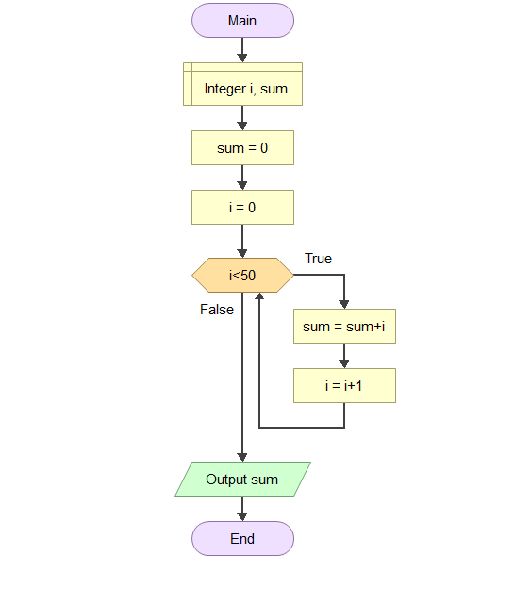

5. Write an algorithm and draw a flowchart to calculate 2^4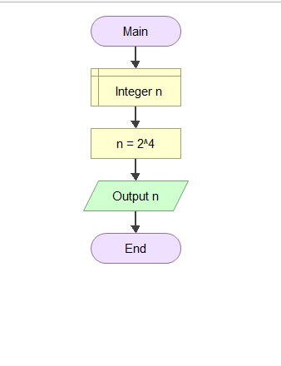

6. Draw a flow chart to find LCM of two numbers.

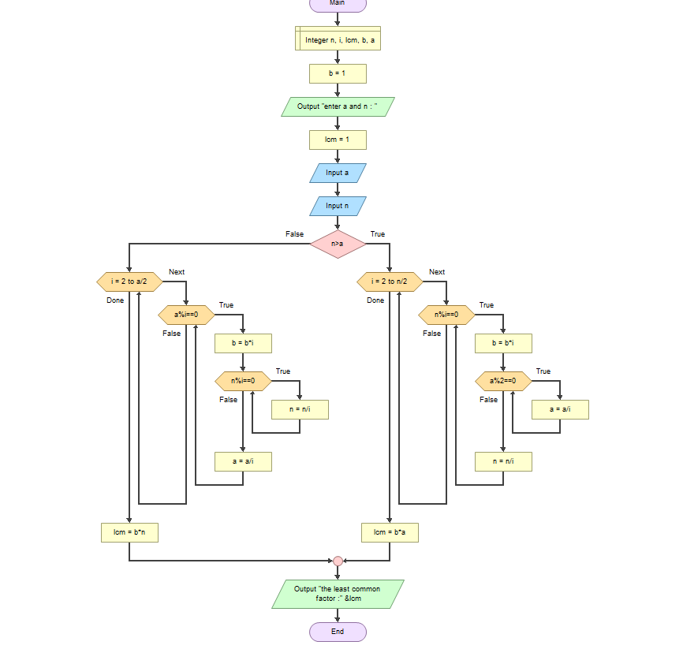

7. Draw a flow chart to print all Prime numbers between 1 to n.

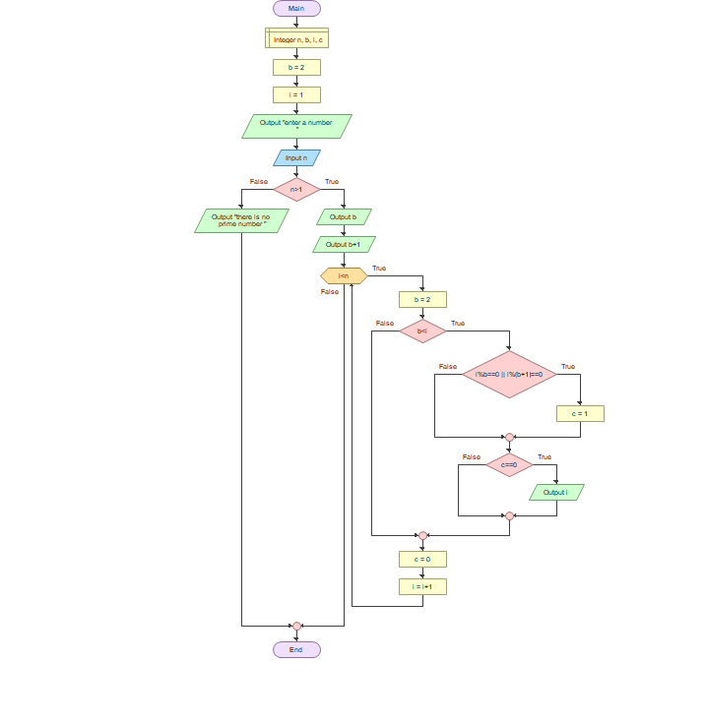

Draw a flow chart to find sum of all prime numbers between 1 to n

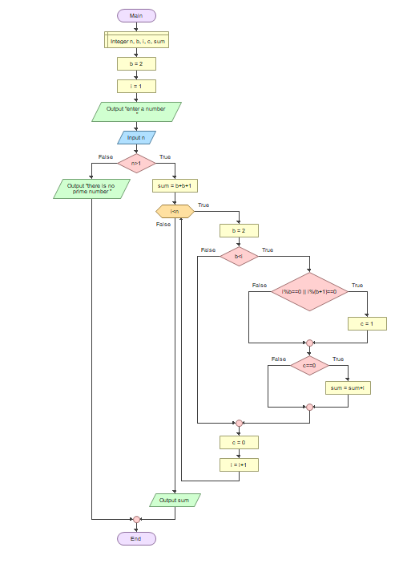

9. Draw a flow chart to check whether a number is Armstrong number or not.

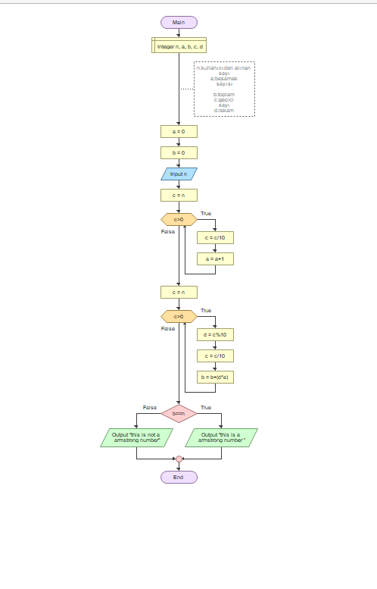

10.Draw a flow chart to print all Armstrong numbers between 1 to n.

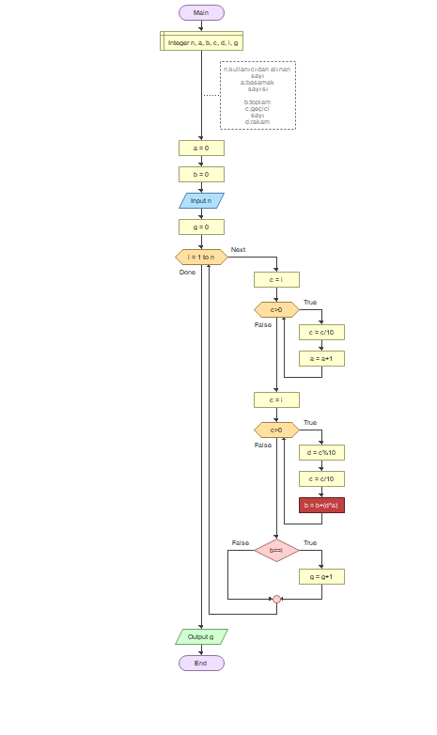

11.Draw a flow chart to check whether a number is Perfect number or not

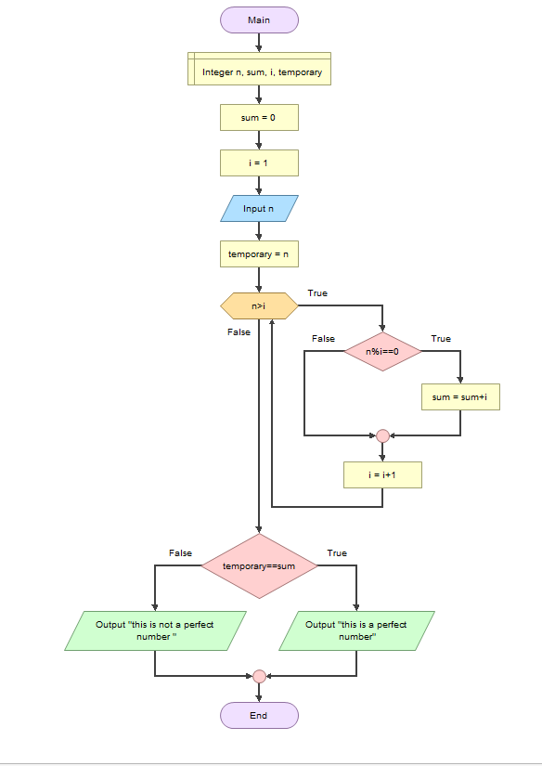

12.Draw a flow chart to print all Perfect numbers between 1 to n.

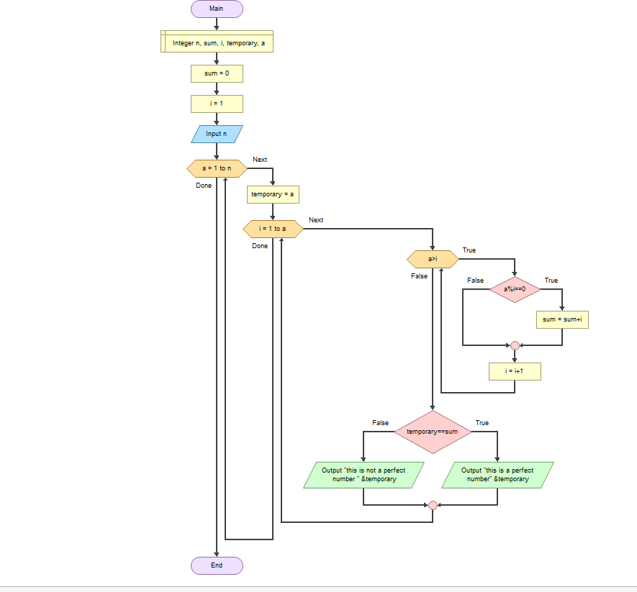

13.Draw a flow chart to check whether a number is Strong number or no

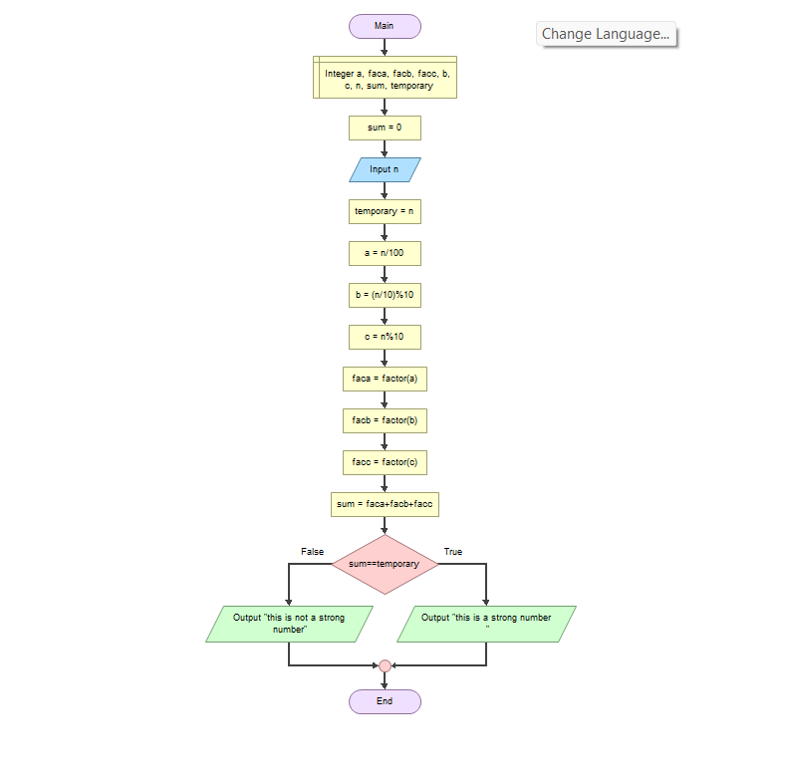

14.Draw a flow chart to print all Strong numbers between 1 to n.

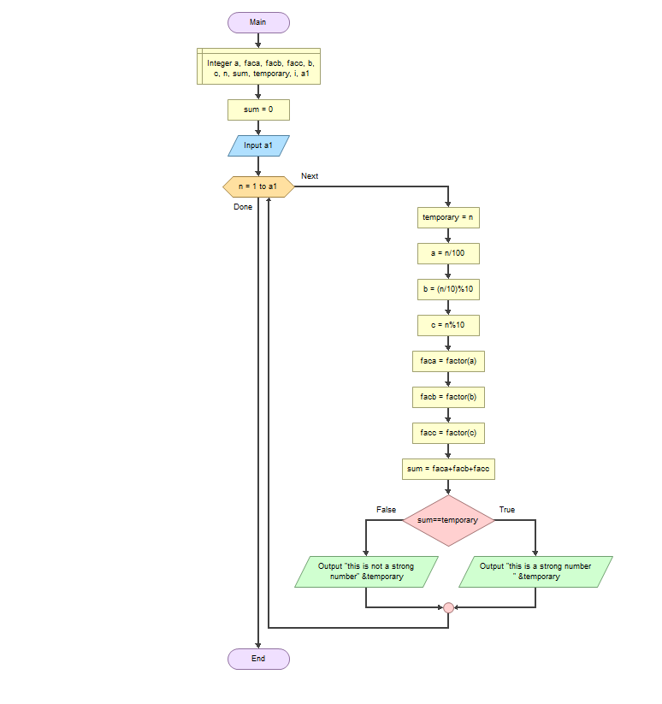

15.Draw a flow chart to check Whether a Number is Palindrome or Not

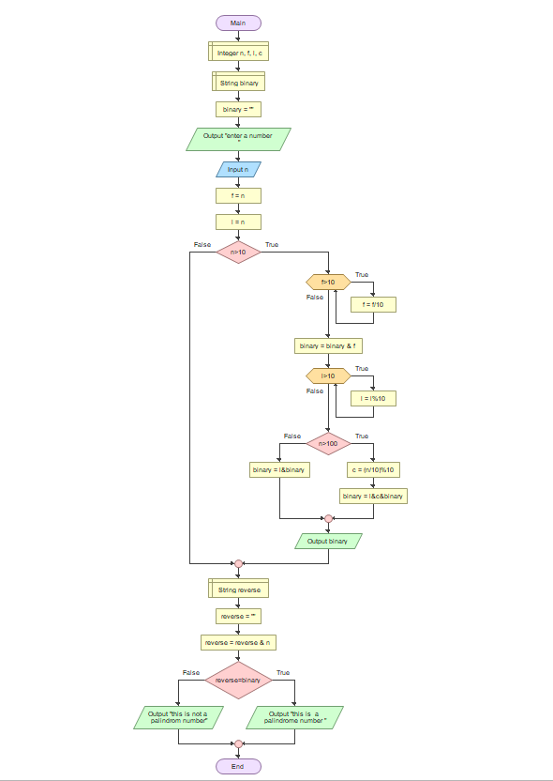

16.Draw a flow chart to find the sum of the series [ 1-X^2/2!+X^4/4!- .........]

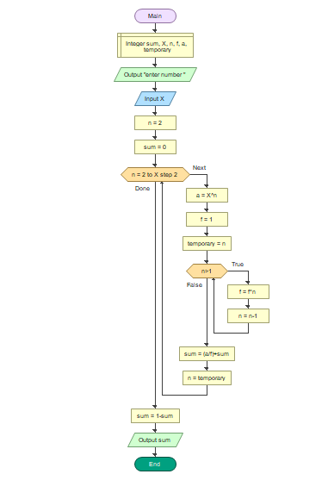

17.Draw a flow chart to display the n terms of harmonic series and their sum. (1 + 1/2 + 1/3 + 1/4 + 1/5 ... 1/n terms)

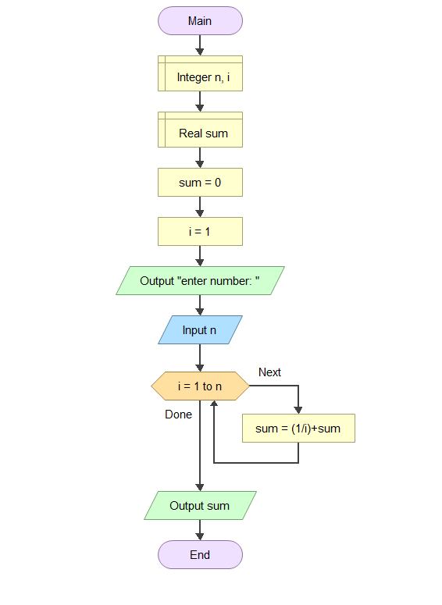

18.Draw a flow chart to print the Floyd's Triangle. 1 01 101 0101 10101

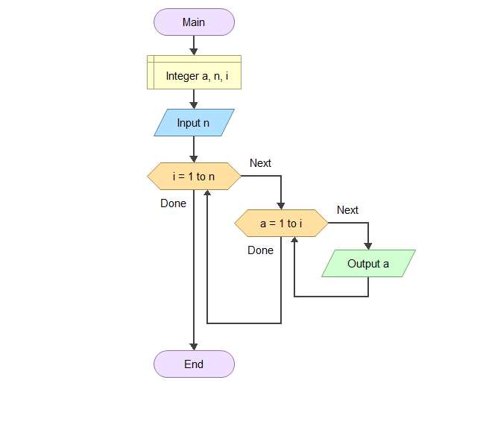

19.Draw a flow chart to display the sum of the series [ 1+x+x^2/2!+x^3/3!+....]

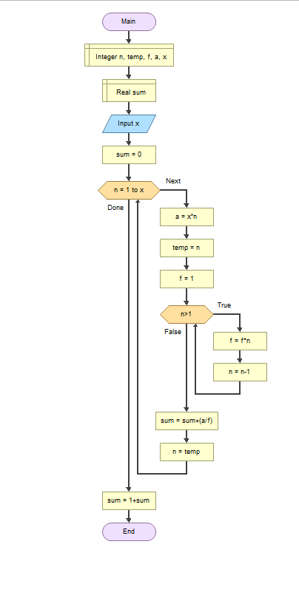

20.Draw a flow chart to find the sum of the series [ x - x^3 + x^5 + ......].

21.Draw a flow chart to find the sum of the series 1 +11 + 111 + 1111 + .. n terms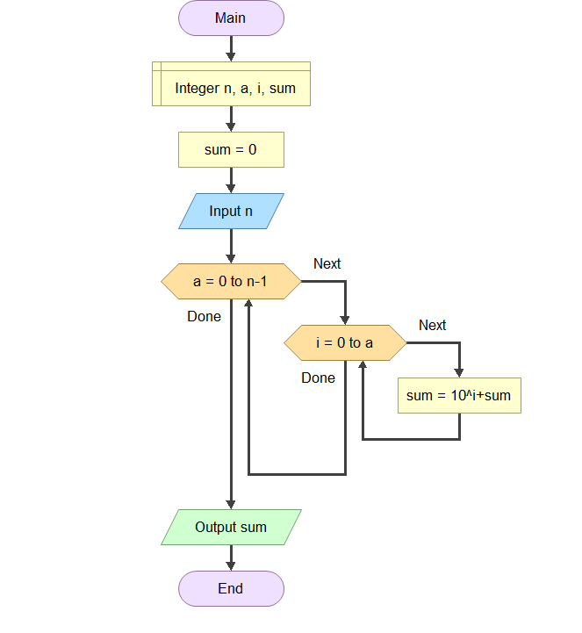

22.Draw a flow chart to find the number and sum of all integer between 100 and 200 which are divisible by 9.

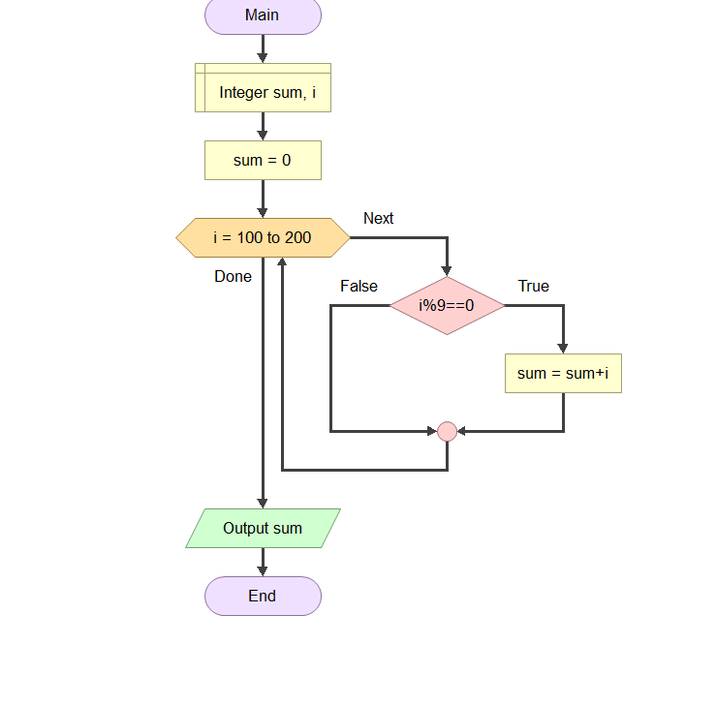

23.Draw a flow chart to convert a decimal number into binary without using an array

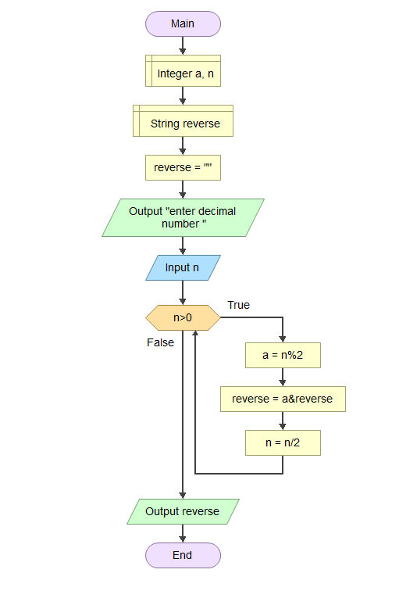

24.Draw a flow chart to convert a binary number into a decimal number without using array, function and while loop.

25.Draw a flow chart to print Pascal triangle upto n rows.

